**Openfield Proficiency Testing Scheme**

**PORTAL Quick Guide**

1. Using **GOOGLE CHROME…**go to [www.optsportal.openfield.co.uk](http://www.optsportal.openfield.co.uk) log in using your email address and then enter your password
2. Click Submit Results …….then Select a subscription/instrument… Select the id number you are putting results in for
3. Select a scheme, select the commodity you are putting results in for
4. Select a round….. select the month that you are putting results in for
5. Tick the “hide” box of the tests you do NOT wish to report
6. If you hide a test by mistake or all the tests you wish to report are not appearing…………. click “Show All Tests”……..

then “unhide” the tests you wish to add in

then click “back to submit”

This will take you back to the page to input your results

1. Type in the Result………Operators Name……….Instrument (from the drop down box)

(If the instrument you are using is not shown please let me know and I will add it to the list)

(**PLEASE DO NOT LEAVE INSTRUMENT BLANK** as this will not allow us to monitor/colour code the bar charts per instrument type)

**IF YOU ARE PERFORMING REFERENCE TESTS (OVEN or 1L KERN or DUMAS or oil NMR/EXTRACTION**……Please make sure **that** result is the one that is “Nominated”

1. Click “Submit Results” at the bottom of the page
2. CHECK the results are correct on the drop down box, (Amend if necessary)…….If happy, click “Commit”.
3. You will receive an email showing what you have sent
4. Return to (3.) to change the commodity for that id or return to (2.) to select a different id.

**If you have ANY problems at all please call us at Honey Pot Lane on 01476 862728**

**Printing Reports from the Portal**

1. Log into the Portal as you would to enter your OPTS results, making sure you are using Google Chrome.

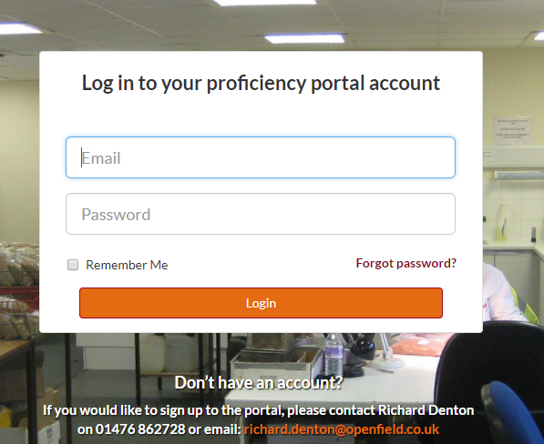

1. 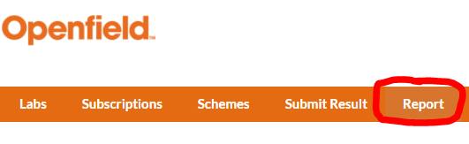Click on the “Report” button in the options bar at the top of the page.
2. 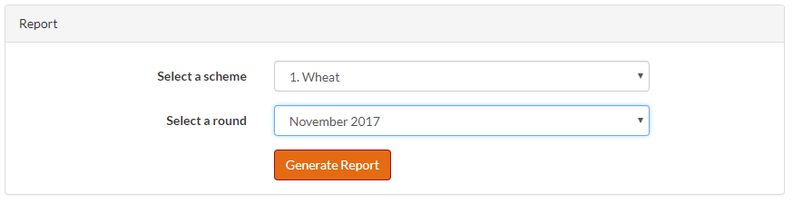From the dropdown options, select the scheme and round you wish to print the report for.
3. Then click on the “Generate Report” button.

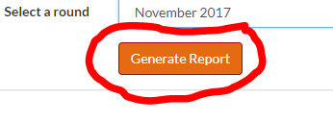

This message will appear to show you it’s working…

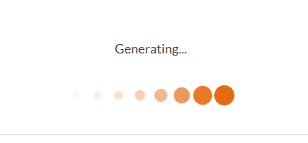

1. All reports for that scheme/commodity will appear and you will be able to scroll through to find your ID number and the graphs at the bottom of the page.

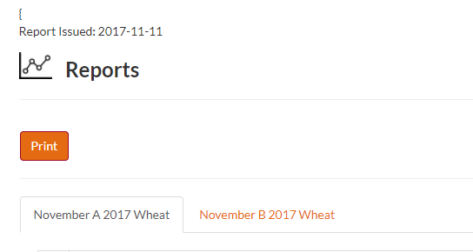

1. To print AND/OR save the reports click the “Print” button.

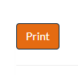

1. The “Print Preview” page will open. If you wish to print a physical copy of the reports, make sure you select to print in colour so you can read the graphs, and double check that the orientation is set to landscape.

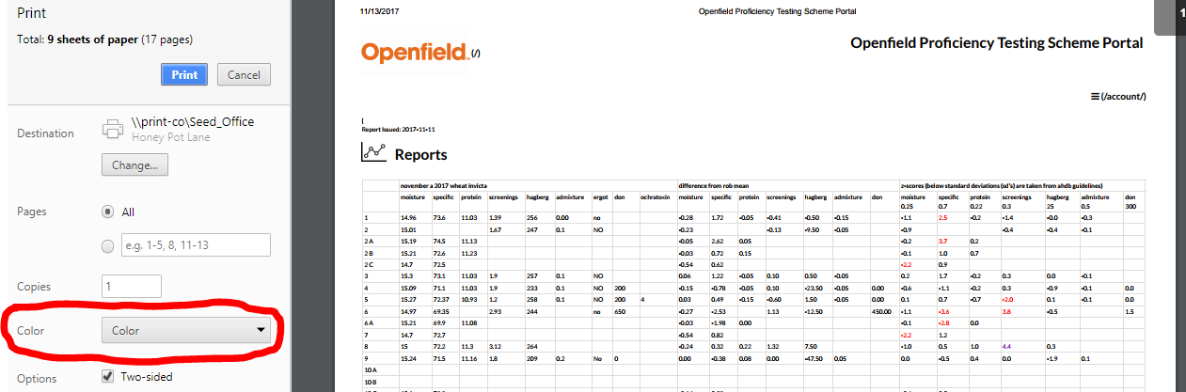

You only need to print once for each scheme, not for each individual report, for example; when you print the reports for wheat you’ll get both Wheat A and Wheat B reports.

1. To save a copy of the reports, click the “Change” button under destination where there is an option to save the document as a PDF file. Click on “Save as PDF”.

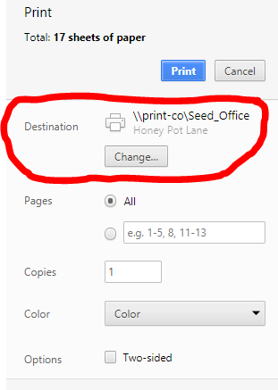

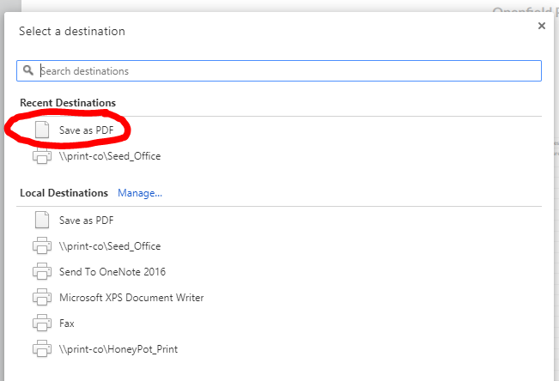

1. You will be taken back the preview screen where you can then click save.

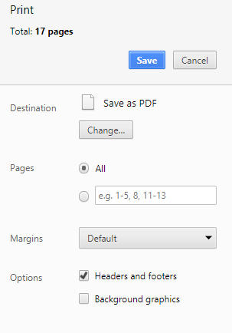

1. Change the file name to OPTS SCHEME ROUND YEAR e.g. “OPTS WHEAT NOV 2017”.

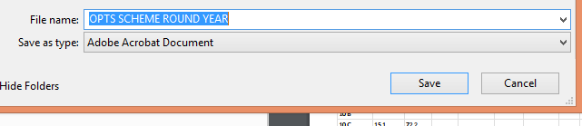

Repeat the process above starting from Step 2 for each scheme/commodity you reported results